**Part 1: Research**

**Example 1:** [**https://www.australianvolunteers.com**](https://www.australianvolunteers.com)

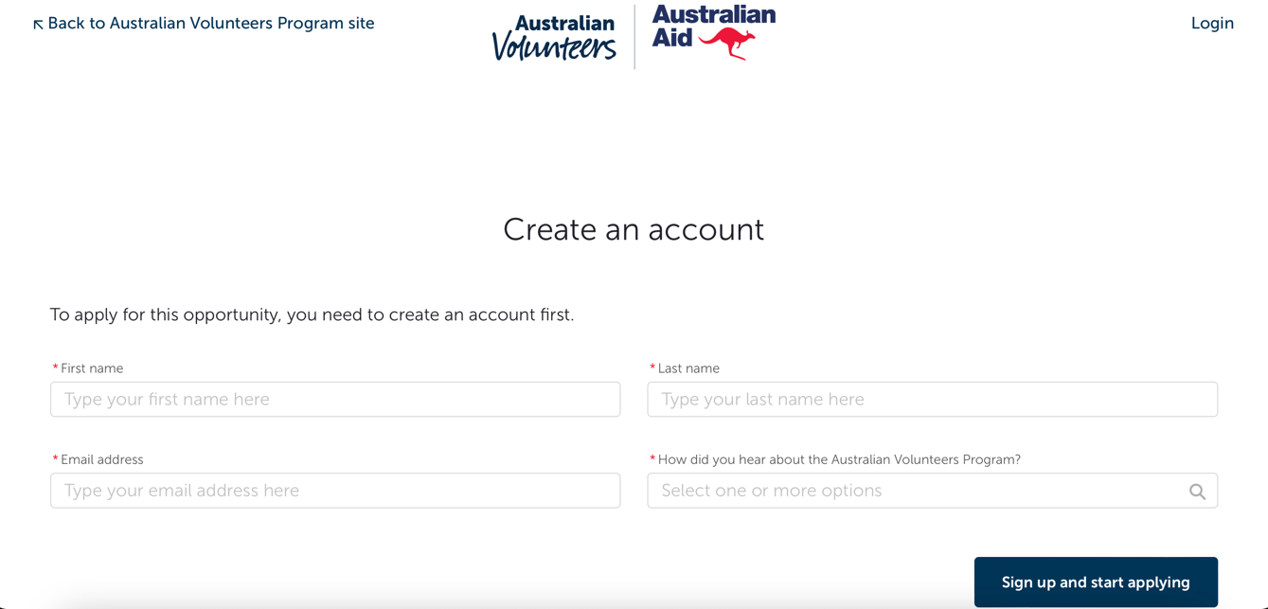

Rather than using a pop up to prompt the user to log in or sign up, the Australian volunteers site opens a new tab. By being clear and simple in style, users are guided through the sign in/up process, allowing for those of all technological skill levels to access the organisation. While this login structure has benefits it may cause synchronisation issues across tabs.

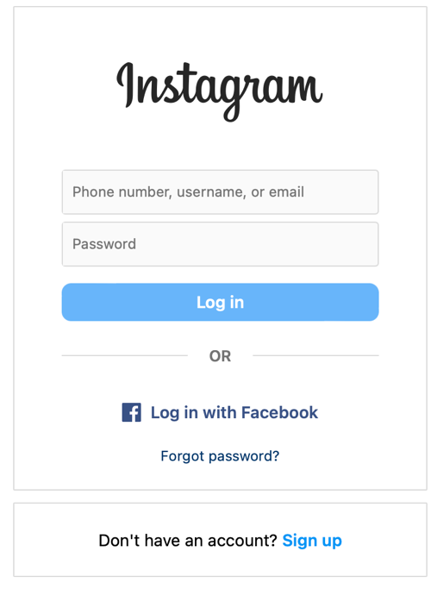**Example 2:**  <https://www.instagram.com/accounts/login/?hl=en>   
  
This is a good example of a log in page. It has the option to login by email or alternately to log in through Facebook. This is likely something we will do in our design as the whole meta system allows for an easy sign in process and connects the user to their own social media. The style of the page is clear and simple, with the sign up section separate from the log in.

**Example 3:** [**https://www.worldpackers.com**](https://www.worldpackers.com)

The WorldPackers website provides an example of a detailed and organised main menu and sub menu. It offers users access to all aspects of the website, providing them information about various volunteering opportunities based on their personal situation and requirements. Although the layout is functional, it is overwhelming, and could benefit from optimising navigation for smoother access to different sections. Upon further inspection it is apparent that such an extensive submenu does not translate to mobile devices or smaller screens. This is not ideal as maintaining two separate designs for different devices can increase development complexity.

**Example 4:** [**https://www.volunteer.com.au**](https://www.volunteer.com.au)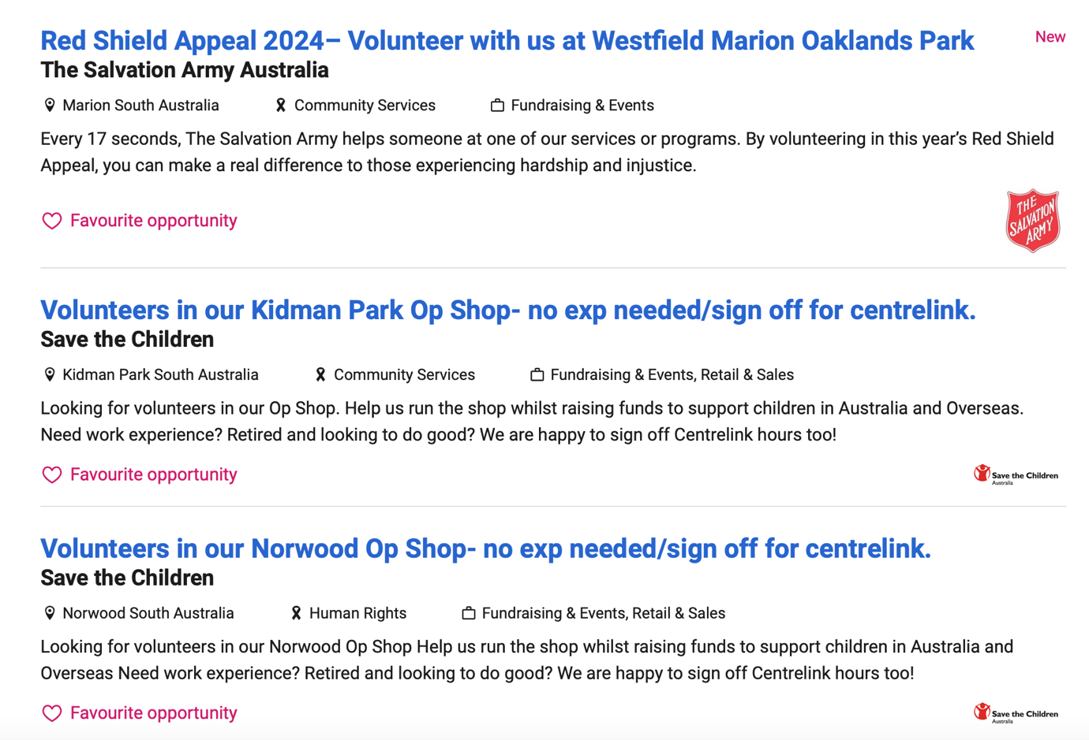

The "Browse Opportunities" section within Seek’s volunteer site allows users to browse various volunteer opportunities and favourite the ones that they have interest in. These opportunities can be filtered by location, cause, and organisation. The organisers who are responsible for the posts can write a description of the opportunity and add tags related to the service. This helps with the filtering process and would be beneficial to include in our site.

**Example 5:** [**https://www.justgiving.com**](https://www.justgiving.com)

The JustGiving website provides a good example of a neat page design with ample white space and automatically centred features. Additionally the site can be used seamlessly between devices (phones, desktops, etc), and the content is organised modularly with reusable components allowing for easy maintenance.

This site has implemented rewards and badges attached to someone’s profile when they donate. This feature could enhance our volunteer site, creating a sense of accomplishment for those who contribute or join numerous volunteer organisations.

**Example 6: https://www.facebook.com/events/create/**

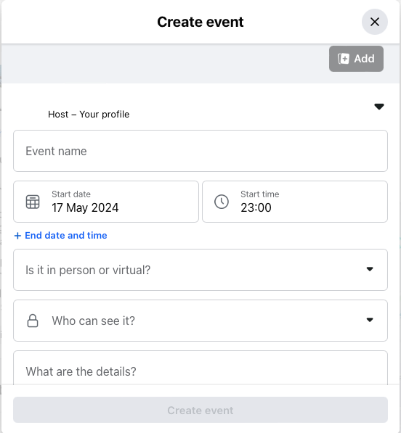Facebook allows for users and organisations to post events, for people to join or participate in. Users can then indicate if they are going, interested, or not going. This will be beneficial to our website for the volunteer’s side of it. On the other side, the image to the left displays how Facebook users can create an event. The features such as the details, the event name, and image and the time are all important to include for our volunteer site. Additionally, like Facebook, there is a drop down for what account to use, so if a client runs multiple volunteer organisations through our website, they can select which one the post is for.